CENWP-OD-B
09 September 2009
MEMORANDUM FOR THE RECORD

SUBJECT: Dead chinook at Bonneville’s Adult Fish Facility (AFF).

On 08 September at approximately 1400, CRITFC researchers reported a dead chinook in the AFF to Project Fisheries. The fish appeared to be in good condition. The fish had been sampled and released to the brail pool where it did not recover. Information collected is provided below:

- Species – Chinook
- Origin – Unclipped
- Length – 80.5 cm
- Weight – Unknown
- Marks and Injuries noted during tagging – None
- Marks and Injuries found on the carcass – None
- Cause and Time of Death – about 1320, unknown cause
- Future and Preventative Measures – NA
- Other – Frozen until fisheries could photograph. CRITFC PIT tagged with Tag # 3D9.1C2D0C799D and half duplex tag # 168384858

08 September 2009 Dead Chinook.

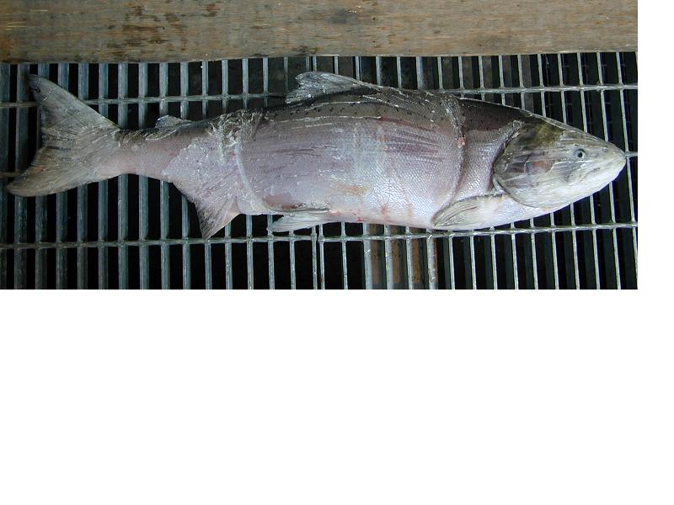
Bonneville Fisheries

